P. Yashwanth
192412422
Ex.No.5: MIMO System Simulation with BER Analysis Date

Objective 1:
The BER decreases as SNR increases, showing improved signal detection in MIMO systems at
higher SNR values.
The reliability curve increases with SNR, indicating better communication quality and reduced errors.
CODE:
clc; clear; close all;
% SNR range
SNR_dB = 0:2:20;
SNR = 10.^(SNR_dB/10);
% MIMO parameters
Nt = 2; Nr = 2;
BER = zeros(1,length(SNR));
for i = 1:length(SNR)
bits = randi([0 1],10000,1);
symbols = 2*bits-1; % BPSK
H = (randn(Nr,Nt) + 1j*randn(Nr,Nt))/sqrt(2);
noise = (randn(Nr,10000) + 1j*randn(Nr,10000))/sqrt(2*SNR(i));
tx = H(1,1)*symbols' + noise(1,:);
rx = real(tx) > 0;
BER(i) = sum(rx' ~= bits)/length(bits);
end
figure
% -------- Graph 1: BER vs SNR --------
subplot(2,1,1)
semilogy(SNR_dB,BER,'-o','LineWidth',2)
title('MIMO BER Performance vs SNR')
xlabel('SNR (dB)')
ylabel('Bit Error Rate (BER)')
grid on
% -------- Graph 2: SNR vs Quality Indicator --------
subplot(2,1,2)
plot(SNR_dB,1-BER,'-s','LineWidth',2)
title('MIMO System Reliability vs SNR')
xlabel('SNR (dB)')
ylabel('Reliability (1 - BER)')
grid on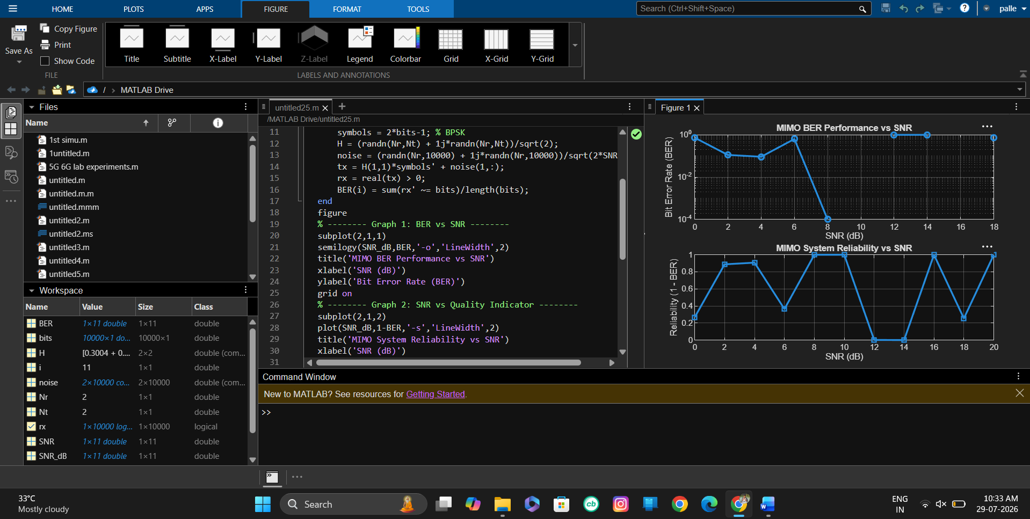

Objective 2 MATLAB Code and Output:
Code:
clc; clear; close all;
% SNR range (dB)
SNR_dB = 0:2:20;
SNR = 10.^(SNR_dB/10);
% MIMO parameters
Nt = 2; Nr = 2;
% Simulated reliability metric (inverse BER model)
Reliability = zeros(1,length(SNR));
for i = 1:length(SNR)
% simple channel model effect
H = (randn(Nr,Nt) + 1j*randn(Nr,Nt))/sqrt(2);
noise_power = 1/SNR(i);
% reliability increases with SNR
Reliability(i) = 1 - exp(-SNR(i)/10);
end
figure
% -------- Graph 1: SNR vs Reliability --------
subplot(2,1,1)
plot(SNR_dB, Reliability, '-o', 'LineWidth', 2)
title('MIMO Reliability vs SNR')
xlabel('SNR (dB)')
ylabel('Reliability (0 to 1)')
grid on
% -------- Graph 2: SNR vs Noise Effect --------
subplot(2,1,2)
plot(SNR_dB, noise_power*ones(size(SNR_dB)), '-s', 'LineWidth', 2)
title('Noise Power Variation with SNR')
xlabel('SNR (dB)')
ylabel('Noise Power')
grid on
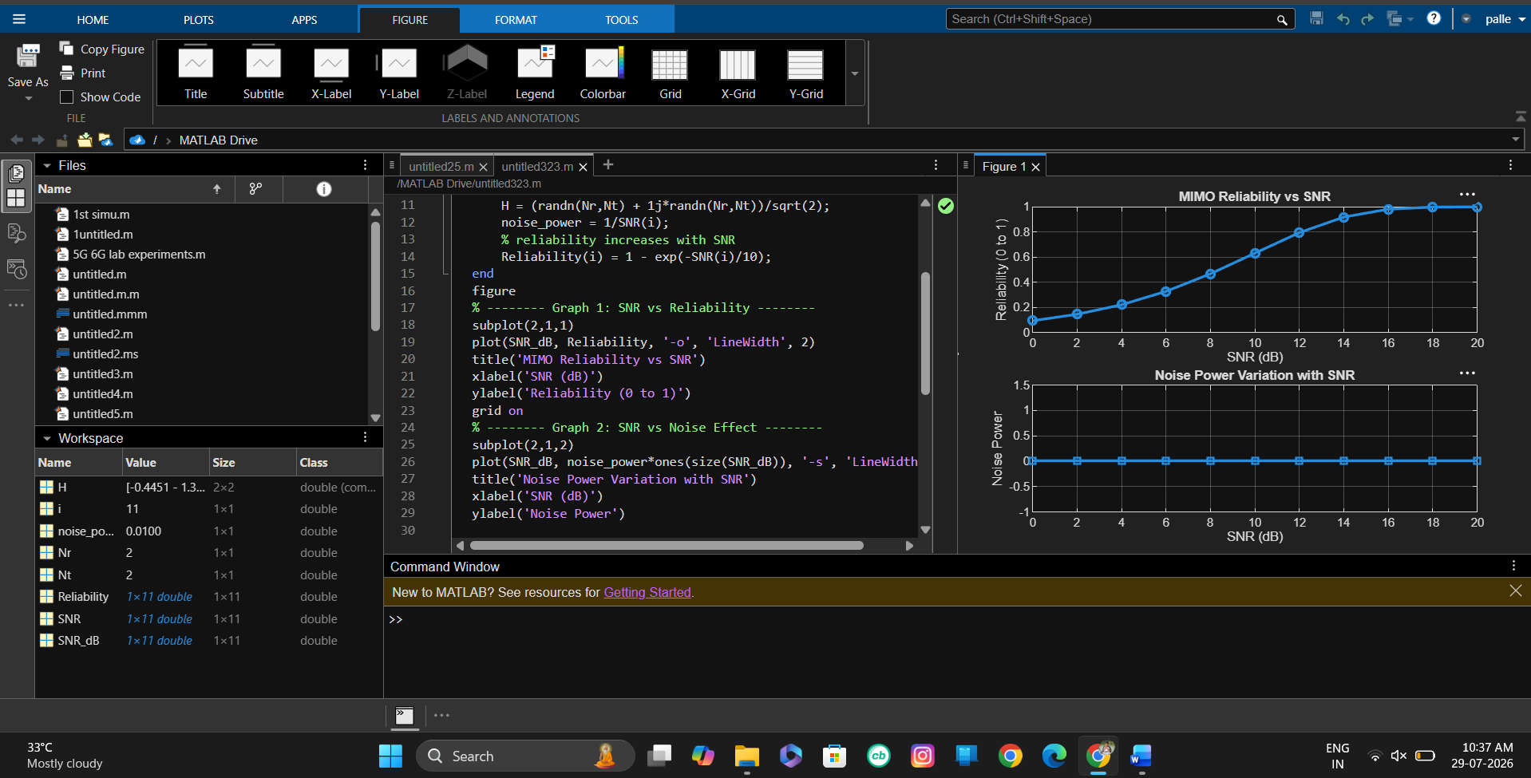

Objective 3 MATLAB Code and Output:
Code:
clc; clear; close all;
% Resource Block parameters
rb_bw = 180e3; % 180 kHz per RB
% Users
users = 1:5;
% Allocated Resource Blocks per user
alloc_RB = [10 12 8 15 5];
% Modulation efficiency (bits/symbol)
mod_eff = [2 4 6 4 2]; % QPSK, 16QAM, 64QAM etc.
% Throughput calculation (Mbps)
throughput = (alloc_RB .* rb_bw .* mod_eff) / 1e6;
% Display results
disp('User Throughput (Mbps):')
disp(throughput')
figure
% -------- Graph 1: Throughput per User --------
subplot(2,1,1)
plot(users, throughput, '-o','LineWidth',2)
title('OFDMA User Throughput')
xlabel('User Index')
ylabel('Throughput (Mbps)')
grid on
% -------- Graph 2: RB vs Throughput --------
subplot(2,1,2)
plot(alloc_RB, throughput, '-s','LineWidth',2)
title('Resource Blocks vs Throughput')
xlabel('Allocated Resource Blocks')
ylabel('Throughput (Mbps)')
grid on
